

ECNL Registration Fees 2026-2027

ECNL Registration Fee Boys & Girls U13-U18: $4200

Included in the ECNL Fees for 2026-27:
La Roca Club Fees
Coach Training Fee
Year Round Training Facilities
Speed & Agility
Game Day Fields *not including RSL game day winter field rental
Game Day Athletic Trainer
UYSA Registration & League Fees
ECNL Registration & League Fees
Referee Fees
HUDL Game Film Storage
High Performance/Development Consultations
Home Game Fees/Expenses
Equipment
Ollie Sports

Not Included in the ECNL Registration Fees for 2026-27:
Player & Coach Travel Fees
Uniform Kit
ECNL National Events & Tournament Registration (these fees vary by team)
Game Filming/Camera System & High Pod - Cameras such as Hudl Flex or Veo and high pods purchased for the team by each team. This also remains with the team each year. Can be sold when the team graduates from youth competition
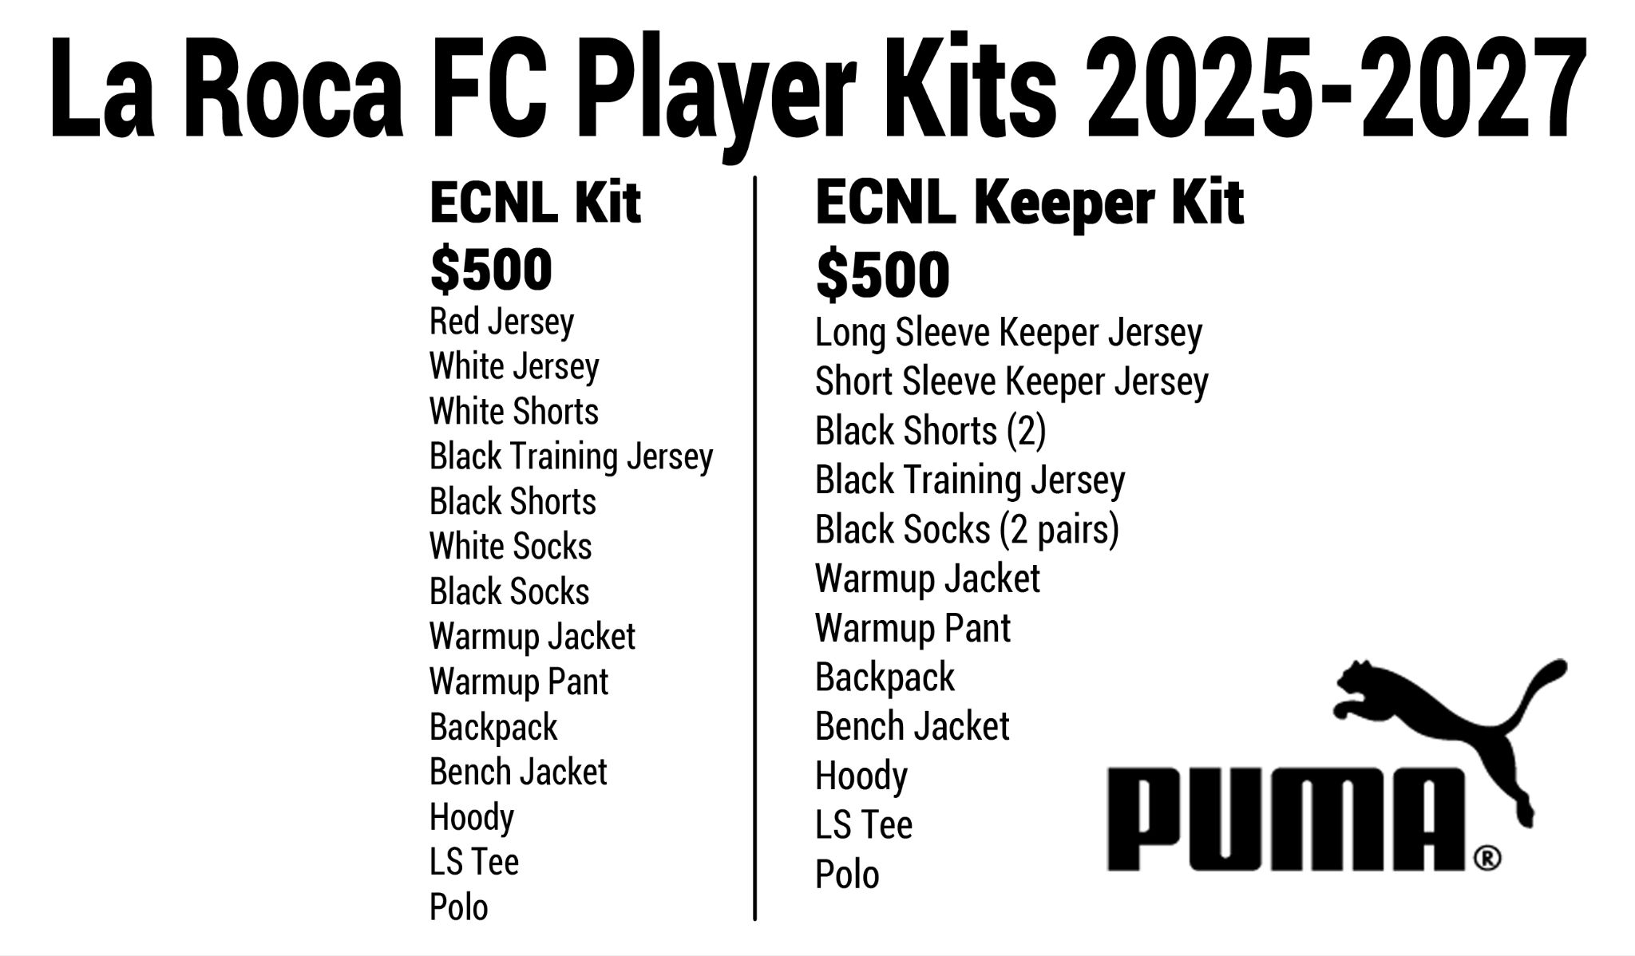
RSL Field Rental for Winter Games

